SC14 Demonstration
Demonstrations during Supercomputing 2014 conference in Louisiana will show a system efficiently moving large LHC scientific data sets between external and internal LHC data centers. The system will consist of dynamically reconfigurable network infrastructure by leveraging the application intelligence through different layers of software and hardware among various end sites. The end sites consists of three booths on the show floor while the external sites include Caltech, CERN, University of Victoria, University of Michigan, and SPRACE. Figure 1 shows the application flow control and how different software components are interacting with each other. The key focus here is on the OpenDaylight SDN controller with added features of OLiMPS multi path component along with MonALISA services which acts as a middleware for providing an overall interface and control from application layer to SDN and hardware infrastructure. Following are some of the software applications which will be used during the SC14 demonstration:
- SDN controller – Intelligent flow based load balancing across multiple network paths. A result from the DOE funded OLiMPS [1] project, currently implemented as part of the open source Floodlight controller, porting in processes to OpenDaylight
- PhEDEx – The CMS data transfer management software enhanced through bandwidth reservation framework, a capability added by the ANSE project.
- ANSE – (Advanced Network Services for Experiments) is an NSF funded project which aims to improve PhEDEx' network awareness for smart source selection, as well as to integrate bandwidth provisioning capabilities in the data transfer management.
- MonALISA – An intelligent middleware software component providing interface between PhEDEx / FDT and the underlying SDN controller.
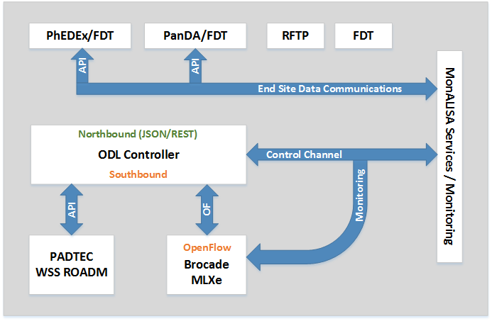
Figure 1: Application Flow Control

High-rate data movement
SC14 demonstration will show case a 1Tbps network connectivity and data transfers among Caltech and iCAIR booths as shown in Figure 3. Caltech will deploy specially designed cache nodes as end servers in this topology in order to meet the massive 1Tbps data throughput. These cache nodes are installed with either SSD SATA drives or SSD based PCIe storage cards. With the evolution of 100GE Ethernet, we are hoping to introduce the world’s first 100GE FPGA based NIC for the cache nodes. Figure3 shows how WAN and local booths are connected using several dark fibers (DF) and 100GE Ethernet connections to SCinet.
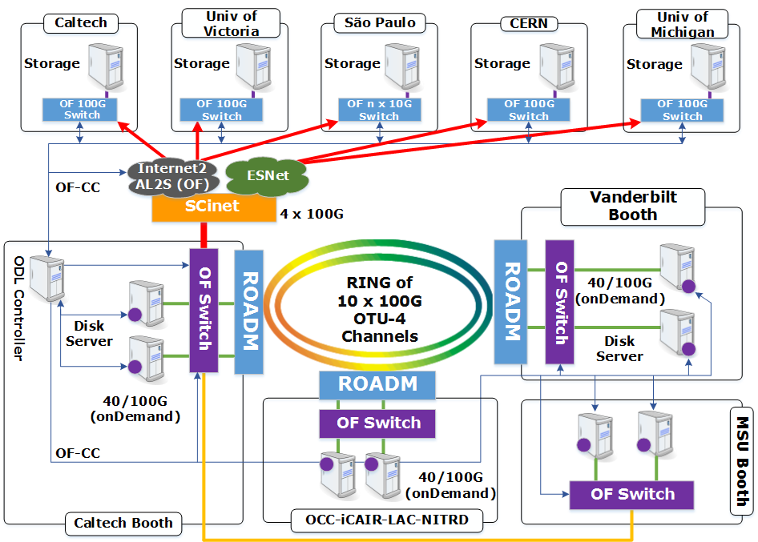
Figure 2: WAN and Inter Booth Connections

Core infrastructure components for the 1Tbps and beyond demonstration includes:
- Padtec wave switch selector (WSS) optical system installed in Caltech, iCAIR and Vanderbilt booths.
- 100GE Brocade OpenFlow supported network switches.
- Disk servers installed with 40GE Mellanox NICs.
- Disk servers installed with 100GE INVEA NIC.

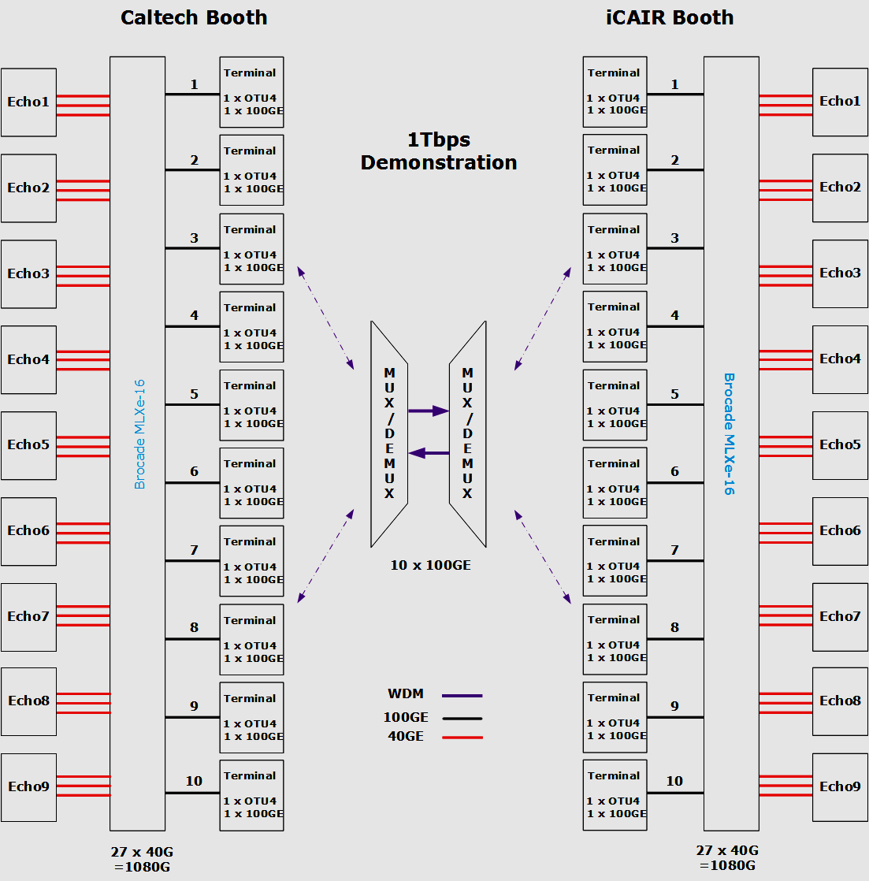
Figure 3 1Tbps Optical Network system

